RE: *Steven De Leon v Edward Diaz and Suncoast Millwork, LLC, Case No: 22-CA-010277, Circuit Court of the Thirteenth Judicial Circuit in and for Hillsborough County, Florida*

Date of Crash: March 2, 2022

Date of Birth: *Steven De Leon:* June 4, 1980 [41 years old at time of crash]

**Background Facts:**

On March 2, 2022, at about 11:50 am Steven De Leon was the helmeted rider of a 2007 Harley Davidson Night Train motorcycle that was eastbound on E. Hinson Ave., making a right turn onto S. 8th St. in Haines City, Florida when a 2008 Ford F-250 pickup towing a 2021 Peach Cargo 16-foot trailer, driven by Edward Diaz with Ashlee Diaz as the front seat passenger, that was southbound on N. 8th St. drove across the intersection and struck the left rear saddlebag of Mr. De Leon’s motorcycle as he was in the process of making his right turn. The impact caused Mr. De Leon and his motorcycle to go down onto the roadway surface. There were conflicting accounts of how the crash occurred between those involved and the investigating police officer. The images below depict the police diagram, a satellite view of the involved intersection, and the subject Harley Davidson, post-collision:

**Police diagram, Mr. De Leon’s Harley Davidson is labeled “V1”**

**Satellite view of involved intersection, image date March 13, 2022**

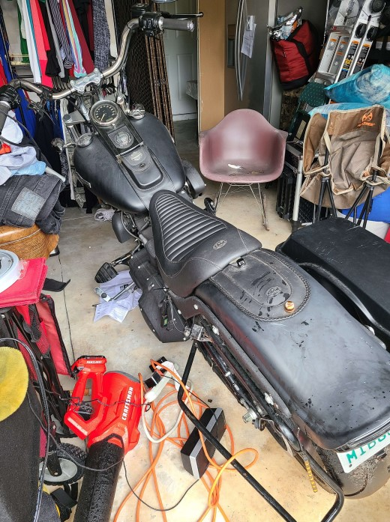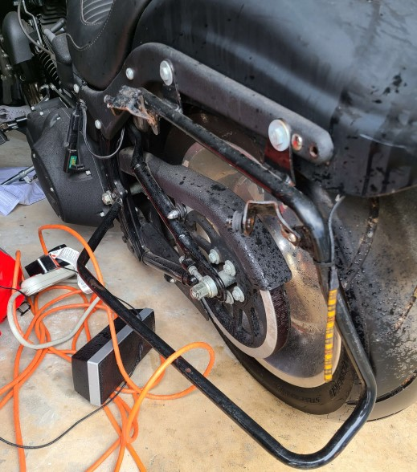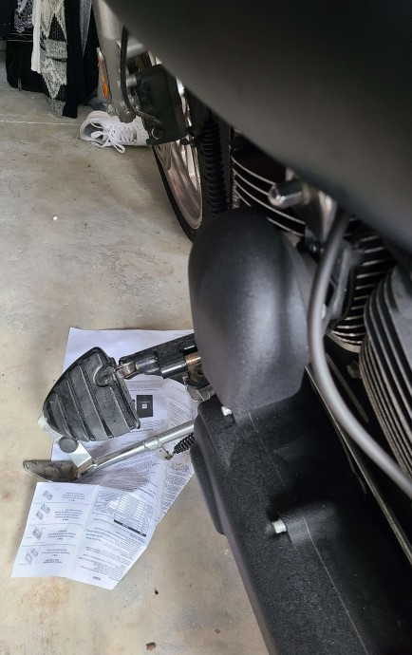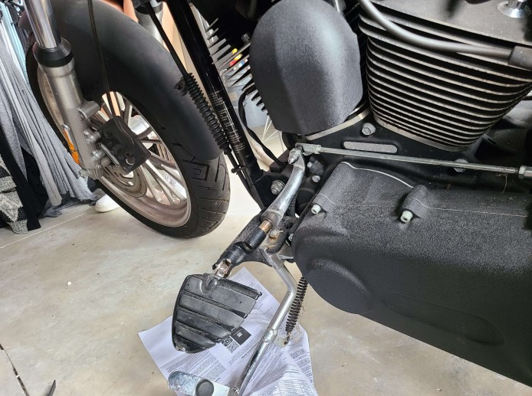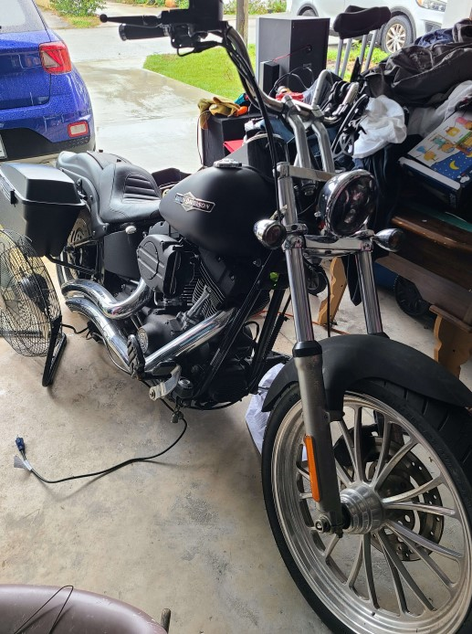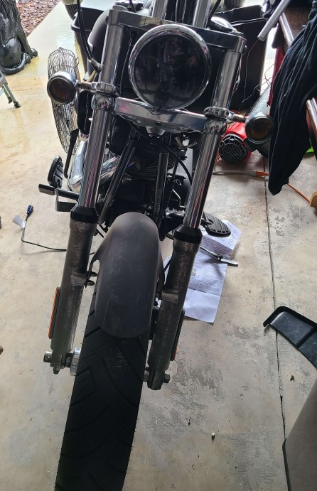

**Mr. De Leon’s Harley Davidson, post-collision**

No damage estimate was provided for the Harley Davidson for review. The provided photos showed damage to the left side saddlebag frame, left footrest/heel shifter and the left front fork appeared to be pushed inwards at the front wheel. No photos of the left saddle bag were provided.

No photos of the Ford F-250 were provided. Mr. Diaz testified that it was not involved or damaged in the subject crash.

No damage estimate or photos were provided for the Peach Cargo trailer; however, the damage was discussed during Mr. Diaz’s deposition. He testified that the damage consisted of a small indentation to the structure that leads from the trailer to the trailer tongue, a small dent in the diamond plating, denting to the tire cover on the starboard (right) side, and denting to the compartment at the right front of the trailer located above the diamond plating along with markings from the motorcycle’s handlebars.

*Post-crash history*

On impact, Mr. De Leon was ejected off his bike/pushed the bike away with his right foot; he fell to the ground (onto his back onto concrete) the bike landed on his left foot and, despite wearing riding boots, the heel shifter impaled the plantar surface of his left foot. EMS responded. Paramedics noted crush injury to the left foot, with anesthesia from the left knee down through the foot (refer to prior history) with a 5–6-inch laceration. (Mr. De Leon was not aware of the left foot injury until paramedics advised him). He also had pain and stiffness in his back. Mr. De Leon was alert and fully oriented, his GCS score was 15. He was initially loaded into the ambulance while awaiting helicopter/Aeromed transportation to the Osceola Regional Hospital ED. Mr. De Leon complained of pain all over (7/10).

In the ED he remained alert and oriented. He reported decreased sensation in the bilateral lower extremities below the knee (refer to prior history), on examination had sustained a small (2 cm) laceration to the dorsum of his mid left foot and a 7 cm linear laceration between the first and second webspace to mid plantar foot; ecchymosis to the dorsum/plantar aspect of his left foot and second toe (his toes were notably well perfused, and he had intact distal pulses). Mr. De Leon also had pain to palpation in his cervical, thoracic, and lumbar spine.

Mr. De Leon underwent X-rays of the head, chest, pelvis, cervical, thoracic, and lumbar spine which were negative for acute intracranial/osseous/intra-abdominal abnormality. CT chest revealed an old, healed posterior left third rib fracture and evidence of prior open reduction and internal fixation of the distal right clavicle. Lumbar radiography revealed unilateral spondylolysis on the right at L5; and an X-ray of the left foot revealed distal second, fourth and fifth metatarsal fractures, proximal and distal left third metatarsal fractures, plantar soft tissue swelling and subcutaneous emphysema. Mr. De Leon was diagnosed with multiple left foot fractures, laceration, and lumbar spondylolysis. His left foot wound(s) were sutured, dressed, and he was admitted for observation.

On February 27, 2022, Mr. De Leon expressed concern that his toe had turned blue, and he had no sensation in the bottom of his left foot. On examination his left second toe appeared blue but was noted to be secondary to bruising; his left foot was warm and well perfused, with decreased sensation in the left heel.

Mr. De Leon underwent a repeat X-ray of the left foot which revealed fractures involving the second, third and fourth and fifth metatarsals, the third metatarsal fractures involved the base and distal portion; acute transverse fracture involving the base of the proximal phalanx of the fifth digit and subcutaneous fluid in subcutaneous air (subcutaneous emphysema). Mr. De Leon also underwent an X-ray of the right foot which was negative for acute fracture or dislocation.

On February 28, 2022, Mr. De Leon was released home. He was prescribed antibiotics, pain, and muscle relaxant medication, and provided with a boot for ambulation.

On March 6, 2022, Mr. De Leon presented to Advent Heath ED with left foot excessive swelling, erythema, and hematoma. On examination, Doppler pulses were intact, his second toe appeared black in color, and he complained of severe pain. He was admitted, diagnosed with an acute post-traumatic wound infection, commenced on intravenous antibiotic therapy, and underwent an emergent **open fasciotomy and multiple compartment decompression with incision and drainage of hematoma, left foot, performed by Dr. Garrett Nguyen (reconstructive foot and ankle surgery).** Post-operative diagnoses included: delayed onset compartment syndrome, hematoma, skin, and tissue infection and closed displaced metatarsal neck fractures (second through fourth).

On March 9, 2022, Mr. De Leon was taken to the OR and underwent an **open fasciotomy decompression of the left foot with debridement and irrigation down to bone level, second digit amputation at the proximal interphalangeal joint and open reduction with internal fixation 2nd through 4th metatarsal neck fractures, performed by Dr. Christopher Reeves (podiatry).**

Post-operative diagnoses included: traumatic necrosis of non-viable tissue, left second digit; open wound status post fasciotomy decompression of the left foot and closed displaced second through fourth metatarsal neck fractures.

CT imaging of the left foot revealed: acute fractures of the metatarsal necks 2-5, acute fracture of the metatarsal base and proximal shaft-3, acute fractures of the proximal phalangeal base-5, prior resection arthroplasty of multiple PIP (proximal interphalangeal) and DIP (distal interphalangeal) joints, and soft tissue swelling adjacent to the fracture sites without evidence of tendon entrapment.

Mr. De Leon remained in hospital, until March 11, 2022, for antibiotic therapy, wound management, and observation. His foot was placed in a cast, and he was released home with prescriptions for Ciprofloxacin 500 mg (oral antibiotics), Toradol 10 mg, Hydrocodone/acetaminophen 5/325 mg (analgesia) and Robaxin 500 mg (muscle relaxant). Mr. De Leon was instructed to follow up with Dr. Reeves on March 22, 2022.

(Mr. De Leon’s cast remained in situ for around 6 months, then progressed to a boot, the wound remained open).

On March 22, and 31, 2022, Mr. De Leon returned to Dr. Reeves. The incision wound was slow to heal, and he had pain and swelling in his lower extremities and difficulty walking. X-rays revealed appropriate post-operative healing.

On April 7, 2022, Mr. De Leon presented to the ED and underwent Doppler ultrasound studies of the left leg due to pain/cramping and swelling. The Doppler was negative for deep vein thrombosis. He was prescribed Norflex and hydrocodone for the pain and released home to podiatry follow up.

Mr. De Leon had subsequent visits to Dr. Reeves on April 28, May 10, and 27, 2022. Dr. Reeves discussed debriding the wound eschar to a granular base (eschar measured approximately 2 cm x 2 cm, plantar aspect left foot) and to follow up in 2 weeks. He also noted the onset of right foot pain on May 27, 2022.

On June 16, 2022, Dr. Reeves diagnosed chronic pain syndrome and phantom pain following the left second digit amputation. Mr. De Leon was referred to physical therapy and returned to Dr. Reeves for further evaluations through January 30, 2023.

On July 16, 2022, Mr. De Leon presented to the Advent Health Heart of Florida Hospital ED with left foot pain, mild right lumbar pain, left flank pain radiating to the right lower quadrant with nausea for the prior 2 days. He was admitted and diagnosed with a [UTI/renal calculi] and infection of the left foot with concerns for osteomyelitis. He commenced a course of intravenous antibiotics and underwent an X-ray and an MRI of the left foot which revealed: second digit amputation at the proximal interphalangeal joint, overlying skin ulceration (0.8 by 0.6 cm) and soft tissue edema without evidence of osteomyelitis; moderate intramuscular and subcutaneous soft tissue edema throughout the left foot likely representing cellulitis.; subacute to chronic fractures involving the neck of the second, third and fourth metatarsals. Mr. De Leon was released home on July 18, 2022, to primary care/podiatry follow up and with a short course of oral antibiotics (cephalexin 500 mg).

Mr. De Leon was unable to wear regular shoes, his gait changed, and he experienced several falls.

On January 5, 2023, he requested a referral to pain management for chronic foot and back pain following a visit to Lajada Claiborne, APRN.

[On March 2, 2023, Mr., De Leon was treated for rhabdomyolysis at Winter Haven Hospital].

On April 12, 2023, Mr. De Leon presented to Dr. Angel Rigueras (physical medicine and rehabilitation) with complaints of persistent pain in his lower back radiating to the bilateral lower extremities with numbness and tingling in both feet, intermittent dizziness, general fatigue, mental fogginess, altered sleep and short/long term memory impairment (he also reported a [recent] fall and had facial bruising around the left periorbital region). Dr. Rigueras diagnosed headache, low back pain, lumbar sprain, lumbar facet syndrome, left foot/ankle joint pain; ordered brain and lumbar spine MRIs and X-ray of the left foot; recommended trigger point /facet and epidural steroid injections, prescribed Celebrex 200 mg, Robaxin 500 mg and encouraged rehab and conservative treatment.

On April 17, 2023, Mr. De Leon underwent the lumbar MRI which revealed: lumbar scoliosis; Grade 1 retrolisthesis of L4 over L5; L2-3, mild facet joint effusion; at L3-4, disk bulge compressing the thecal sac, mild facet joint effusion; at L4-5, diffuse disk bulge compressing the thecal sac and causing narrowing of the bilateral neural foramina, and bilateral facet joint arthropathy.

X-ray of the left foot which revealed: subchondral cysts in the head of the first and second metatarsal bone; proximal end of the proximal phalanx of the second digit (distal part of the proximal phalanx and mid and distal phalanx of the second digit not visualized); and periarticular osteopenia.

X-ray of the left ankle revealed: periarticular osteopenia without evidence of fracture.

On May 9, 2023, Mr. De Leon presented to Dr. Frank McCormick (orthopedic surgery). He expressed concern for RSD (reflex sympathetic dystrophy syndrome) and recommended Mr. De Leon see a foot and ankle specialist.

On May 16, 2023, Mr. De Leon returned to Dr. Rigueras and underwent bilateral lumbar facet joint injections at T12-L1 and L1-2. Mr. De Leon had complete pain relief but for a few hours only.

On May 23, 2023, Mr. De Leon returned to Dr. McCormick with persistent pain in his lower back radiating to the bilateral lower extremities with numbness and tingling. Dr. McCormick ordered electromyography/nerve conduction velocity (EMG/NCV) studies of the left lower extremity.

On May 30, 2023, Dr. Rigueras repeated the lumbar facet joint injections, bilaterally at L3-5 (without significant effect). Dr. Rigueras discussed proceeding with lumbar rhizotomies.

On May 31, 2023, Mr. De Leon underwent EMG/NCV of the left lower extremity, performed by Dr. Pallavi Cherukupally (physical medicine and rehabilitation) which revealed: a bilateral chronic L5 radiculopathy, and evidence of diffuse peripheral neuropathy affecting both the tibial and peroneal nerves.

On October 10, 2023, Mr. De Leon presented to Dr. Richard Fansler (general surgery) in Tampa, for evaluation of possible left below-knee amputation due to persistent pain in the left foot radiating up his entire leg with occasional shooting pains in his thigh (he had also recently fallen and injured the anterior surface of his left shin). Mr. Leon was utilizing crutches and non-weight bearing. Dr. Fansler noted a chronic draining sinus possibly representing osteomyelitis versus hardware infection on the plantar surface of the left foot. Dr. Fansler discussed amputation as a last resort and recommended treatment of the deformity and drainage stemming from the plantar surface of the left foot. He also recommended seeking evaluation for further treatment/considerations for amputation or medial foot surgery, nearer to home (Orlando).

On November 21, 2023, Mr. De Leon presented to Dr. Andrew Mundy (orthopedic surgery) with constant stabbing pain in his left foot and ankle (numbness in his toes). He also complained of repeated falls over the past several years. Dr. Mundy diagnosed neuropathic left foot with associated ankle arthrosis, sinus tract on the plantar aspect of the left foot without evidence of acute infection. He suggested repeating X-rays of the left tibia and left foot.

On December 19, 2023, Mr. De Leon was provided with a new CAM boot for ambulation and referred to Podiatry to discuss possible below knee amputation following evaluation with Dr. Brian Goldman (orthopedic surgery).

On February 2, 2024, Mr. De Leon underwent MRIs of the thoracic spine, left foot, left ankle, ordered by Dr. Rigueras. The thoracic spine revealed: at T4-5, and 6-7, posterior disk bulging impinging on the thecal sac.

The left foot study revealed: marrow contusions in the head of the fifth metatarsal bone; subcutaneous edema around the dorsal aspect of the foot.

The left ankle study revealed: marrow edema/bone contusions along the distal tibial epiphysis extending into the distal shaft of the tibia; 25% partial tear of the anterior tibiofibular and spring ligaments; joint effusion and subcutaneous edema around the ankle.

On February 23, 2024, Dr. Rigueras performed an intra-articular left knee injection. Height: 5 ft 7 inches, weight: 110 lbs.

*Pre-crash medical history*

Mr. De Leon was involved in two prior traffic crashes in New York, prior to moving to FL (in 2019) without injury.

Mr. De Leon was in a motorcycle crash in 2013 resulting in a right shoulder injury, pain in his right ribcage and left foot (ecchymosis on the dorsum of the left foot and in the first and second toes), abrasions to both hands and left knee.

X-ray of the left foot revealed non-displaced fractures of the base of the distal phalanx of the great toe and base of the middle phalanx of the second toe.

X-ray of the right shoulder revealed: oblique midshaft clavicle fracture with comminution, with 1.5 cm of displacement and 2 cm of shortening.

**Mr. De Leon underwent an open reduction and internal fixation of the right clavicle on October 29, 2013, performed by Dr. John McLaughlin (orthopedic surgery).**

Mr. De Leon subsequently developed chronic right axillary neuropathy, chronic low back pain/ lumbosacral radiculopathy, and right carpal tunnel syndrome.

On July 15, 2015, Mr. De Leon underwent evaluation with Michael Ciaffone (NP). He diagnosed multiple joint pains, leg cramps when walking, and chronic right shoulder pain with bilateral hand paresthesias; referred Mr. De Leon to a nerve specialist and orthopedics. Mr. De Leon was also treated for Vitamin D deficiency and prescribed Norco, Celebrex, and Nortriptyline for pain management.

Mr. De Leon had hammertoe deformity of the left foot /toes with chronic toe pain. He was under the care of Dr. Timothy Fishman (podiatry) and underwent **hammertoe corrective surgery involving the left second, third, fourth and fifth toes on October 22, 2016.**

Mr. De Leon underwent physical therapy for low back pain, right shoulder pain, abnormal gait/mobility and mononeuropathy in April 2017.

On July 28, 2021, Mr. De Leon was evaluated by Janine Kyte APRN secondary to bilateral leg pain and paresthesias, and numbness in his groin area. He was referred to neurology and prescribed gabapentin.

Mr. De Leon was diagnosed with migraine headaches and seizures secondary to traumatic head injury in 2010.

Mr. De Leon was being treated for bipolar disorder

Tobacco smoker; one pack/day. Smoker since the age of 9 years

*Medical and other records reviewed for history*

Steven De Leon, deposition November 14, 2023

Polk County Fire Rescue

Tampa General Hospital (TGH) Aeromed

Advanced Diagnostic Group

Osceola Regional Medical Center ED

Advent Health, operative reports

Regenerative Sport Spine and Spa, Dr. Cherukupally

True Health

Coastal Mental Health Center

Tampa Bay Surgical Group, Dr. Fansler

Advent Health of Florida Hospital ED (July 16, 2022)

University Orthopedic Care

Upperline Health, Orlando Foot and Ankle, Clinic (records and imaging)

Peak Physical Therapy (prior)

Cappa Podiatry (prior)

Cross Valley Health & Medicine (prior), Michael Ciaffone NP

Hudson Valley Imaging (prior)

St. Luke’s Cornwall Hospital, prior surgery (right clavicle)

True Health-Lake Underhill (prior)

Winter Haven Hospital

*Reconstruction:*

According to the police report it was daylight, clear and the roadways were dry. The listed speed limit on E. Hinson Ave. was 45 mph; however, a review of Google Earth street view showed 30 mph speed limit signs. No speed limit information for N. 8th St. was provided. A review of Google Earth street view did not show any speed signs on N. 8th St., however, a 25 mph speed sign was seen on S. 8th St.

Mr. De Leon, deposed on November 14, 2023, testified that he was traveling eastbound on E. Hinson Ave. in the left lane and moved into the right lane in preparation to make a right turn onto S. 8th St. There weren’t any vehicles ahead of him in the right lane, but there were vehicles ahead of him in the left lane. As he was making his right turn, he was struck from his left while he was in the turning position. He did not see the vehicle that struck him before the impact, and he was hit on his left rear saddlebag. The left side of his motorcycle went down and the heel shifter on his motorcycle went through his foot even though he was wearing motorcycle riding boots. He did not know how fast he was going before or at the time of the crash but said he always goes the speed limit. When asked if he told the police officer that he didn’t see the trailer he replied that he never told him that.

Mr. Diaz, deposed on November 15, 2023, testified that he was driving a 2008 Ford F-250 and pulling an empty 16 foot trailer when the crash occurred. His wife, Ashlee Diaz, was in the truck with him as well. They were at the stop bar (on N. 8th St.), traffic (on E. Hinson Ave.) was stopped due to a traffic light and there was a gap in traffic for him to go across. He began to go across the intersection, got to the middle of the intersection, slowed, looked left-right-and left again and then continued across. He looked to his right again and saw Mr. De Leon’s motorcycle coming at an unknown speed and he brought his truck and trailer to a stop. He did that so Mr. De Leon would not crash into the flat side of his trailer and to also give Mr. De Leon some room to come in between his truck and trailer, which Mr. De Leon did. He also stated that Mr. De Leon swerved to the right, went over the sidewalk just prior to the crash occurring, went in between his truck and trailer and his bike ended up laying down on the road. He watched the impact occur, saw Mr. De Leon hit his trailer, saw him fly into his handlebars, and then fall over. Mr. De Leon did not catapult over the tongue of his trailer and land on the far side of it. He got out of his truck to check on Mr. De Leon and saw him sitting on the ground screaming that he did not see the trailer.

Officer Nave, deposed on May 30, 2023, testified that when he arrived on the scene, he saw Mr. De Leon laying down on the sidewalk on E. Hinson Ave. and his motorcycle was laying on its left side, but he could not remember where it was specifically located. The damage on the motorcycle was on its front and left side and the damage to the trailer was on the box section behind the tongue. He remembered seeing gouge marks and debris, including a saddlebag, on E. Hinson Ave. but was not able to remember where it was specifically located because he did not take any photos or video at the scene. His investigation revealed that Mr. Diaz’s truck had penetrated and crossed the intersection, Mr. De Leon came up, he did not see the trailer and the motorcycle impacted the trailer. Mr. De Leon did not lay his bike down. Mr. De Leon made a spontaneous statement to him that he did not see the trailer while they were still at the crash scene. His listed 45 mph speed estimate of the motorcycle in the report was just a guess and it was not based on any calculations or other evidence.

In his police report he stated that:

* Mr. De Leon was travelling east on E. Hinson Ave.
* Mr. Diaz was traveling south on N. 8th St., pulling a trailer, and crossing E. Hinson Ave.
* Mr. Diaz established control of the intersection, the Ford pickup had cleared the intersection, and the trailer was still in the process of crossing through it when the impact occurred.
* Mr. De Leon failed to yield to Mr. Diaz and struck the trailer where the tongue connects to the trailer, and he was ejected off of the motorcycle.
* Mr. De Leon spontaneously told him that he did not see the trailer while on scene and no statements were obtained from him at the hospital.

No deposition of Ms. Diaz or any other statement from her was provided for review.